At home with a sibling who has Autism

Educational Psychology Service
Someone with autism might:
- Have problems understanding
- Have problems taking part in everyday life
- Need to know what is going on all the time, and be in control
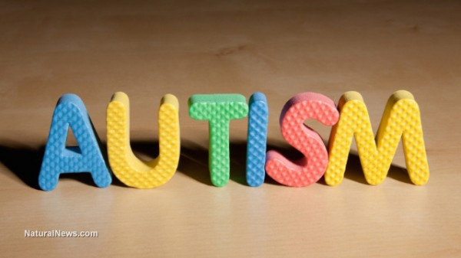

These things might make them angry, frustrated, or confused, which might mean that they:
- Find it hard to tell someone how they feel
- Not understand what someone says, or take something the wrong way
- Not understand what is wrong unless someone clearly tells them
- Find it hard to take part in some activities, especially pretend games
- Find new situations difficult
- Like doing the same things every day
- Do not understand danger
- Hurt themselves or others, and sometimes shout, swear, or run away
- Flap their hands, rock from side to side, or spin around and around
Schools are closed at the moment because there is a virus.
We are all staying home to stay safe, this means we can’t go out the house very often and some of us can’t go out at all.
By staying home, we will help stop the virus spreading.

When the virus goes away, we will be able to go back to school.

Because someone with autism might find new situations difficult and enjoy doing the same things every day, they may be feeling:
- Sad
- Angry
- Confused

They may not understand that it is important to stay home.
If they are upset, they may seem angry as they might not know how to tell someone how they are feeling.
Instead, they may flap their hands, rock from side to side, hurt themselves or others, or shout, swear, or try to run away.
We must remember they are not trying to be nasty to us.

We may all be feeling a bit upset at the moment, which means we might behave a bit differently too.
When we are feeling this way it is important to tell an adult so that they can help us.
It is very important that we are all kind to each other, especially someone with autism as they might not understand.

To be kind, we could:
- Allow them time to calm down if they get angry
- Have kind hands, kind feet, and kind words
- Play games that they understand, where we don’t have to pretend
- Be clear and give them time to understand
- Give them space when they want
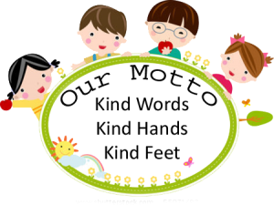
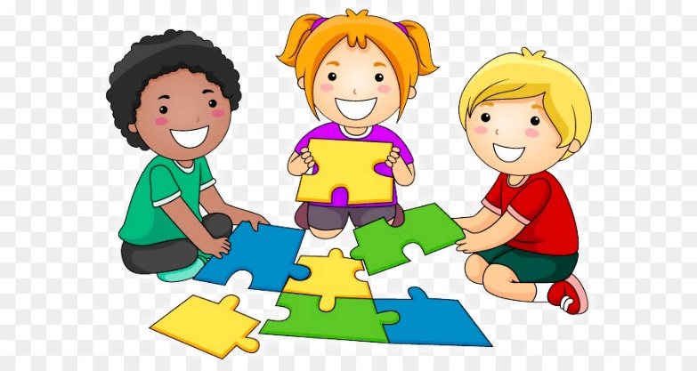

If we all make small adjustments and look after each other, we will be able to manage staying at home better.

