 

**Performance Development**

**for**

**School Leaders and Staff**

**A new approach to appraisal.**

**Model Policy for schools 2024 – 25**

**Including recommended and example templates**



| **DOCUMENT CONTROL** | |
| --- | --- |
| **Policy Name** | Performance Development for School Leaders and Staff |
| **Department** | Human Resources PCC |
| **School** | Milford Haven School |
| **Reviewing Officers - PCC**  **- MHS** | Partneriaeth on behalf of the 3 constituent Local Authorities  CA Morris & D John |
| **Review Date - PCC**  **- MHS** | September 2022  December 2022, December 2023, May 2025 |
| **Next schedule review date** | ~~December 2024~~ May 2027 |
| **CONSULTATION PROCESS** | |
| The following Trade Unions have been consulted in respect of this Policy:   * ASCL * NAHT * NASUWT * NEU * UCAC * Unison * GMB * Unite | |

**Contents**

| **1.** | **Introduction** | **4** |
| --- | --- | --- |
| **2.** | **Principles underpinning Performance Development** | **5** |
| **3.** | **Purpose** | **6** |
| **4.** | **Continuous professional/performance development** | **7** |
| **5.** | **Professional standards** | **8** |
| **6.** | **How to use the professional standards** | **9** |
| **7.** | **Evaluating your progress** | **10** |
| **8.** | **Appointment of reviewer** | **12** |
| **9.** | **The Individual Performance Plan and Review** | **13** |
| **10.** | **Improvement in Learners Learning** | **13** |
| **11.** | **Additional Considerations for Headteacher Review** | **14** |
| **12.** | **Professional Support/ Peer Review** | **15** |
| **13.** | **Feedback from Reviewer** | **15** |
| **14.** | **Monitoring Activities** | **16** |
| **15.** | **Upper Pay Scale** | **17** |
| **16.** | **Returning after extended period of absence** | **17** |
| **17.** | **Managing underperformance** | **17** |
| **18.** | **Monitoring and evaluation of this policy** | **18** |
| **19.** | **Appeals** | **18** |
|  | **Development cycle** | **20** |
|  | **Recommended and Exemplar Documents** | **21** |
|  | **Appendix 1 – Appeals Panel Members** | **22** |

**Drafting note**

This model policy refers to the statutory arrangements for the performance management of teachers and headteachers. When using this model policy schools are encouraged to also consider the performance management arrangements of all their staff. There is currently no statutory provision for the performance management of support staff, but it is considered to be best practice for a school to have appropriate arrangements in place for all members of staff and provisions have been included in the policy. Schools may adapt this model policy accordingly while still having regard to statutory provisions.

For the ease of understanding, some of the terminology from the statutory arrangements have been amended such as an appraiser is referred to as a reviewer.

1. **Introduction**
   1. This policy has been produced in collaboration with the three Local Authorities (Carmarthenshire County Council, Pembrokeshire County Council and City and County of Swansea) within the Partneriaeth Consortia. It has been developed to comply with the requirements of the School Teacher Appraisal (Wales) Regulations and the Welsh Government guidance on Performance Management.
   2. This model policy refers to the statutory arrangements for the performance management of teachers and headteachers using a ‘Professional/Performance Development Model’, therefore in this policy ‘performance management’ has been replaced with ‘Performance Development; a different perspective and a new direction designed to challenge thinking, promote deep reflection, collaboration and change for the better. Supporting schools as learning organisations.
   3. When using this model policy, schools are encouraged to consider the professional/performance development arrangements of Headteachers, senior leaders, teachers, and all other staff registered with EWC and are working with learners in the classroom. There is currently no statutory provision for the performance development of support staff, but it is considered best practice for schools to have appropriate arrangements in place for all members of staff. Members of staff that are registered with the EWC and work with learners in the classroom have therefore been included in this policy. All other staff should follow the local performance management processes in place for NJC staff. Please contact local HR/L&D department for details.
   4. This policy sets out the ‘Performance Development’ arrangements for staff of Milford Haven School. It has been agreed by the Governing Body, Head Teacher and follows consultation with all staff members and recognised trade unions. It describes the principles, purpose, procedures, roles and responsibilities that will ensure that the school’s performance development arrangements contribute to the professional development of its staff. It will also contribute to the achievement of wider development objectives for the school and its learners. The policy will be reviewed annually and any necessary amendments will be the subject of further consultation with staff members.
   5. This policy provides a framework for a clear and consistent approach to the development of staff and expectations that all staff should aspire to. It is a policy based on professional trust. It is a supportive process intended to foster professional dialogue between colleagues. **It is assumed therefore, unless evidence suggests otherwise, that staff are meeting the Professional Standards required for their role**. Whilst using them to identify where they focus for further development.
   6. The policy will be reviewed annually by Partneriaeth, and any necessary amendments will be the subject of further consultation with key stakeholders.
   7. The headteacher will provide the Governing Body, as part of the headteachers report to governors, an annual update on the operation and effectiveness of this policy including professional development needs arising from the performance development process. The Chair of Governors or Chair of the Committee dealing with Headteacher Performance will report on the operation and effectiveness of the headteacher’s performance development process.
   8. The current appraisal regulations and accompanying guidance published by the Welsh Government can be found at:

**Regulations**

[www.legislation.gov.uk/wsi/2011/2940/contents/made](http://www.legislation.gov.uk/wsi/2011/2940/contents/made)

**Guidance**

[www.wales.gov.uk/topics/educationandskills/publications/guidance/performance-man-for-teachers?lang=en](http://www.wales.gov.uk/topics/educationandskills/publications/guidance/performance-man-for-teachers?lang=en)

<https://hwb.gov.wales/api/storage/f87e720f-8568-4a60-9383-55e20b9a1bb7/schools-in-wales-as-learning-organisations.pdf>

* 1. This policy does not apply to:
* newly qualified teachers (NQTs) undergoing their statutory period of induction who are exempted from performance management arrangements
* teachers employed for a fixed period of less than one school term
* teachers, headteachers and teaching support staff subject to formal capability procedures
* staff undertaking a probationary period. (Schools induction procedures should be used to cover this period)
* supply / casual members of support staff who work rarely within the school.
* Adjusted performance development arrangements will apply to staff who have only been at work for part of the performance development cycle. This will include reviewees:
* returning from parental leave including maternity, paternity, shared paternal and adoption leave
* on or returning from long-term sickness absence
* who join or leave the school part way through the cycle
* who come out of other arrangements during the performance development cycle, including probation, statutory induction and capabilities.

1. **Principles underpinning Performance Development**

Performance development is a school improvement tool which is fully inclusive. It sets a framework for teachers and school leaders to agree and review priorities and objectives in the context of the school’s improvement plan. Performance development provides the opportunity of a shared commitment to achieving high standards. It helps to focus attention on more effective teaching and, therefore, benefits pupils, teachers and the school.

* Trust, confidentiality and professional dialogue between reviewer and reviewee.
* Commitment by all to engage actively and cognitively with the process of professional/performance development.
* Consistency so that all staff are treated fairly.
* Recognition of strengths and a commitment to share effective practice and an understanding of improvements needed.
* A commitment to providing constructive feedback on performance.
* Rigorous and evidence based.
* A shared commitment to meeting the school’s improvement plan priorities, appropriate local authority and national priorities.
* The policy is intended to be developmental and supportive.
* Creating and supporting continuous learning opportunities for all staff.
* Promoting team learning and collaboration among all staff.
* Establishing a culture of enquiry, innovation and exploration.
* Learning with and from the external environment and wider learning system.
* Modelling and growing learning leadership.
  1. The Governing Body is committed to ensuring that the performance development process is a fair and non-discriminatory process.
  2. The Governing Body recognises the entitlement of the work/life balance for teachers and the headteacher as established within the School’s Pay and Conditions (Wales) Document (STPC(W)D), and are encouraged to ensure the work life balance of all members of staff.
  3. The Governing Body must adhere to Equalities legislation in the application of this policy and make reasonable adjustments where appropriate.

1. **Purpose** 
   1. Performance development is an approach that helps school staff become the very best versions of themselves; supporting them to make the next steps whilst creating a culture of belonging and to help ensure that members of staff are able to continue to improve their professional practice and to develop within their role.

* 1. Performance development has several purposes;
* To build and enhance expertise, and secure continuous professional development and improvement.
* To enable reflection on strengths and successes, and areas for development.
* To recognise and promote a culture of professionalism.
  1. Effective performance development is an essential part of securing effective teaching and leadership. The performance development model requires a desire and willingness to engage in continued professional development. It is designed to create a shared commitment for all school staff who will support one another to develop, so that all learners benefit from the highest quality teaching. The model enables leaders to support each other so that the school benefits from the highest quality leadership. This cannot be achieved by professional learning alone. Performance development is designed to change the way we view accountability and professional development. It is a process that requires a commitment from all staff to engage actively and cognitively in order to seek further growth in professional knowledge that provides solutions to the issues faced by school staff. Performance development is ‘done by’ not ‘done to’ staff within the school.
  2. There is a shared sense of belief and pride that staff can be the very best, driven by a sense of moral purpose and a desire to continually improve. Professional development is regarded as a key driver not only to staff development, but also to recruitment, retention, wellbeing, and school improvement.

1. **Continuous Professional/Performance Development**
   1. Effective, and genuinely continuous, professional/performance development…

* Has a focus on improving outcomes for learners in relation to the four purposes, principles of progression, achievement and attainment.
* Builds and enhances knowledge and expertise to bring about changes in practice
* Has a narrow yet significant focus
* Acknowledges that knowledge and expertise is context specific
* Recognises that novice and experts learn differently
* Focuses on what works, challenges existing assumptions and is, therefore, evidence informed
* Involves collaboration with colleagues and peer support
* Is sustained over time and includes frequent opportunities for learning; experience and practice, reflection and evaluation, professional enquiry, honest frequent and solutions-focused coaching.
* Creates a culture of aspiration and agency as opposed to judgement and task completion
* Governors are committed to making available resources for staff to undertake appropriate training to enable them to succeed.
  1. The education of learners is of primary concern, and we are accountable for achieving the highest standards in work and conduct.
  2. The Professional Standards
* are not a checklist and should not be used as such.
* are used to frame professional learning and development needs
* define the level of practice expected of school staff
* set out a number of expectations about performance development
* can be used as a tool to form the basis of the discussions in a performance development review meeting, driven by the reviewee’s self-reflection, aspirations, ambition and professional challenge.
* are put in place to provide a member of staff with an honest reflection of where they feel they are performing as a practitioner
* provide a mechanism of showing practitioners areas where improvement can be made and where practitioners can share their skills and experience with others.
  1. Note - The way a reviewee assesses themselves against each of the standards may change over time, with aspects that they might consider a strength one year becoming a focus for development in another year, as they grow and develop as a professional. This should be viewed as a positive, as it demonstrates robust self-reflection.
  2. Staff should
* Keep their knowledge and skills up-to-date, be self-critical and reflective
* Take responsibility for improving and understanding how learners learn and how this has an impact on their role
* Have a secure knowledge of the relevant subjects/AOLEs and curriculum for Wales
* Reflect systematically on the effectiveness of their roles
* Know and understand how to access the relevant subject and curriculum areas linked to their role
* Leaders should have a secure knowledge of a range of leadership strategies and know when and how to use them
  1. Employers should
* Ensure all elements of this policy is adhered to at all times
* Ensure time is allocated during directed time for performance development discussions and check in sessions to take place.
* Ensure an assessment of workload is undertaken, as part of the review process, to limit additional workload pressures in the application of this policy
* Ensure that goals are not linked to numerical targets
* Provide all staff with suitable professional development opportunities
* Ensure the reviewer agrees with the reviewee monitoring activities that link to individual goals at the beginning of the review cycle and keep these under review with the reviewee during check in sessions.
* Ensure the relevant legislation is adhered to at all times i.e. Equalities.
* Mindful of work life balance, wellbeing and equity for all staff
* Ensure written records are kept for at least 3 years after the next statement has been finalised.

1. **Professional standards**
   1. The standards concentrate on the essential elements of every teacher’s, leader’s and teaching assistant’s work - pedagogy, collaboration, leadership, innovation and professional learning – and will help underpin the development of the teaching profession as it leads the transformation of our education system in Wales. They have been developed with the profession, for the profession, to be relevant to all staff registered with EWC and who work with learners in the classroom.
   2. Each standard is divided into elements with descriptors that exemplify how the standards could apply to a member of staff's work depending on where that member of staff is in terms of their role and career.
   3. The Induction level descriptors for teaching describe expectations that should be met for the award of QTS and the successful completion of statutory induction. These need to be achieved before a teacher can gain QTS.
   4. The sustained highly effective practice descriptors exemplify what is expected in order to become a sustained highly effective practitioner and provides a focus for career-long professional learning.
   5. The lower descriptors for formal leadership show the expectations of a formal leadership role and the upper descriptors exemplify highly effective practice in a formal leadership role.
   6. The lower descriptors for the assisting teaching show the expectations of teaching assistants and the upper descriptors exemplify the expectations for higher level teaching assistants (HLTA).
2. **How the standards should be used for performance development**
   1. Professional standards are used to inform professional learning, practice and innovation at a school.
   2. Practising teachers and leaders must continue to meet each of the five entry-level strands as they fulfil their work. In the event that an individual is not meeting the entry-level standards then a discussion between the reviewer and reviewee needs to take place to avoid the possibility of capability procedures being undertaken (see Capability Policy).
   3. The standards have a number of elements supported by a range of descriptors, which practitioners should use to review their development. The descriptors **should not** be used as a checklist but should be regularly reviewed by practitioners to assist their professional learning throughout their careers.
   4. All staff registered with the EWC who work with learners in the classroom are encouraged to use the Professional Learning Passport (PLP) on the EWC website or other similar reflection tools to record, reflect and review professional learning activities, events and enquiries.
   5. Performance development involves effective self-reflection, review and evaluation to ensure that staff members identify areas for further growth and continue to maintain the level of competence that qualified them at the start of their careers. It should be noted that a few support staff may have been appointed prior to the standards being introduced. These staff should be supported to become familiar with these standards.
   6. Members of staff should use the relevant professional standards to self-evaluate their performance prior to their review meeting with their line manager. The professional standards should be considered as a whole to provide a backdrop to discussions and to help practitioners identify areas for further development.
   7. The evidence used to reflect on performance and development **will not** be solely based on student data or a small number of lesson observations. There is a commitment to developing a professional culture, which drives quality assurance from within; an enabling process rather than an imposed, top-down process. Therefore, schools will have no high stakes observations and staff should not be held to account for data-driven targets that no one individual can be solely accountable for.
   8. The relevant professional standards can be found at:

<https://hwb.gov.wales/api/storage/19bc948b-8a3f-41e0-944a-7bf2cadf7d18/professional-standards-for-teaching-and-leadership-interactive-pdf-for-pc.pdf>

[professional-standards-for-assisting-teaching-interactive-pdf-for-pc.pdf (gov.wales)](https://hwb.gov.wales/storage/1f42779c-2002-4bb3-8d8d-b7bd56fca32e/professional-standards-for-assisting-teaching-interactive-pdf-for-pc.pdf)

1. **Evaluating your progress**
   1. Staff will need to take personal responsibility for developing their practice through appropriate professional development. Performance development will be linked to school or subject/AoLE improvement priorities and to the on-going professional development needs and priorities of individual members of staff and, of course, the learners they teach and support.
   2. In order for performance development to be successful, the following criteria need to be addressed:
   3. Teachers will:

* Reflect on their successes, strengths and areas for further growth against the Professional Standards.
* Reflect on the Professional Standards at the start of the cycle to establish an individual focus for performance development, which is then further detailed in the ‘Individual Performance Plan’. Each teacher, therefore, needs to carefully reflect on their current context, standards and practice to ascertain the most impactful development focus. The focus will then be discussed and established with the support of the reviewer. This discussion will take place in the first half of the Autumn term.
* This focus is then sustained over time and all staff are required to engage in opportunities for learning and with alternative pedagogical approaches, reflection and evaluation, feedback and coaching. It is intended that professional development and learning, rather than just being confined to meetings in specific times and places, will become embedded into teachers’ everyday work practices.
* Regularly reflect on their progress of the ‘Individual Performance Plan’ as they design lessons to purposely practise the focus of their ongoing learning and subsequently reflect on the effectiveness of any changes in practice.
* Be given the opportunity to present to colleagues at the end of the develop cycle the key areas of learning from their development work for the benefit of reflection, and sharing of effective practice.
* Engage appropriately with any whole school/partnership performance development priorities within the context of their role.
* In addition, a TLR holder or member of staff on the leadership pay scale will have a goal linked to their leadership development or specific area of responsibility. This goal will be recorded in the Individual Performance Plan.
  1. Headteacher / Senior Leaders will:
* Reflect on their successes, strengths and areas for further growth against the Professional Standards for Leadership.
* Reflect on their own leadership and management style and the impact this has on bringing about effective change.
* Reflect on the Professional Standards for Leadership at the start of the cycle to establish an individual focus for performance development, which is then further detailed in the ‘Individual Performance Plan’. The headteacher / senior leader, therefore, needs to carefully reflect on their current context, standards and practice to ascertain the most impactful development focus. The focus will then be discussed and established with the support of the governor performance development panel. This discussion will take place before the end of the autumn term.
* This focus is then sustained over time. Headteachers / senior leaders are required to engage in opportunities for learning and with alternative pedagogical approaches, reflection and evaluation, feedback and coaching. It is intended that professional/performance development and learning, rather than just being confined to meetings in specific times and places, will become embedded into leaders' everyday work practices.
* Regularly reflect on their progress of the ‘individual performance plan’ as they design strategies for whole school improvement to purposely practise the focus of their ongoing learning and subsequently reflect on the effectiveness of any changes in practice.
* This sustained development work will be presented to the full governing body at the end of the cycle for the benefit of reflection, accountability and future decision-making.
* Engage fully with any local authority/partnership performance development priorities.
  1. Support Staff will
* Reflect on their successes, strengths and areas for further development/growth against the relevant Professional Standards for assisting teaching.
* Reflect on the relevant Professional Standards at the start of the cycle to establish an individual focus for performance development, which is then further detailed in the ‘Individual Performance Plan’. Each member of staff, therefore, needs to carefully reflect on their current context, standards and practice to ascertain the most impactful development focus. The focus will then be discussed and established with the support of the reviewer. This discussion will take place in the autumn term.
* This focus is then sustained over a significant amount of time and all staff are required to engage in opportunities for learning and with alternative pedagogical approaches, reflection and evaluation, feedback and coaching. It is intended that professional/performance development and learning, rather than just being confined to meetings in specific times and places, will become embedded into the member of staff’s everyday work practices.
* Regularly reflect on their progress of the ‘Individual Performance Plan’ as they support learners learning, to purposely practise the focus of their ongoing learning and subsequently reflect on the effectiveness of any changes in practice.
* Be given the opportunity to present to colleagues at the end of the develop cycle the key areas of learning from their development work for the benefit of reflection, and sharing of effective practice.
* Engage appropriately with any whole school/partnership performance development priorities within the context of their role.

1. **Appointment of Reviewer**
   1. The headteacher will appoint a Reviewer for every member of staff in the school.
   2. The Reviewer will normally be the line manager of the reviewee i.e. Headteacher, Teacher, Business Manager. Where the reviewer is not the reviewee’s line manager a discussion will take place with the member of staff to agree the reviewer.
   3. For teachers, the reviewer must have QTS.
   4. The headteacher may appoint a new reviewer in place of an existing reviewer at any time. The member of staff should be notified in writing of the reason why such change is necessary, and this note should be attached to the Individual Performance Plan. The Reviewer will conduct all aspects of the review in accordance with Welsh Government guidance.
   5. The headteacher’s review will be carried out by a panel consisting of:

* at least two governors appointed by the governing body
* one or two representatives appointed by the local authority, one of whom may be a school improvement officer.
* a representative of the Diocesan Authority for faith schools

1. **The Individual Performance Plan and Review**

*What knowledge and skills do we need to address the learning needs of our learners?*

* 1. For staff to answer this question, they are asked to take control of their professional learning and plan for how they will meet the needs of their class, specific class/es, groups, individuals or whole school priorities: ‘the individual performance plan’.
  2. For performance development to be truly continuous and sustained over time, each member of staff formulates an ‘individual performance plan’. This requires each member of staff to reflect on current practice and subsequently build their expertise through sustained focused inquiry and frequent purposeful practice.
  3. The individual and unique plan will identify what a member of staff hopes to learn or do differently, and the approaches to achieve this: content and process. The individual performance plan also requires staff to identify the possible impact of their work on outcomes for learners, although it is recognised that in the complex process of staff development/growth, any impact on learners’ outcomes is difficult to directly correlate.
  4. Relevant information from Individual Performance Plans may be taken into account by headteachers, school governing bodies (including committees of governing bodies), Chief Education Officer under regulation 31 in taking decisions, and in advising those responsible for taking decisions, about the promotion, and any discretion in relation to pay. Before using information as part of any other employment process i.e. discipline, a discussion should take place with HR.
  5. Individual Performance Plans are confidential documents and must be kept in a secure place. The provisions of the UK General Data Protections Regulations must be followed.

1. **Improvement in learners' learning is the central purpose of the process.** 
   1. Therefore, the ‘individual performance plan’ requires the learning to be a continuous, in depth process, as this is likely to have a much greater impact on the practice and outcome for the learners than brief and superficial ‘training’ that lacks focus and context.
   2. In the ‘individual performance plan’ clear goal/s are set with each member of staff – a focus on what to change or develop further with intended impact. Value is placed on the importance of autonomy and choice in the focus of each individual’s development, and an understanding that by providing staff with opportunities to substantially affect and direct their own goal/s, practice and inquiry is a powerful motivator. Between one and three goals should be set. Goals should also not relay on attainment/progress data to judge success. Professional learning must be driven by an individual’s motivation to become even better rather than being told what to do. Teachers, leaders and support staff who work with their line manager to set and monitor their own goal/s are those that are likely to continue to grow as professionals. Effective training, opportunities and time will be given to staff to provide them with sufficient support to work effectively on their goal/s and this will maximise the impact of learners' learning and progress.
   3. The focus for the bespoke plan will be chosen within parameters and staff are expected to connect their work to the year group they teach/support and/or school priorities. Knowledge and expertise are content specific; expertise requires knowledge and skills in a specific area. **Any professional learning must therefore be as specific as possible to the context in which it will be used, e.g., the year group/subject being taught/support being provided to individuals/groups and/ or school priority.** With clear goal/s and an assessment of what is needed to achieve them, support can be then focused on meeting those needs.
   4. The ‘individual performance plan’ is a ‘live’ document and the expectation is that it is reflected/reviewed on and referred to frequently, adjusted where appropriate, but always forms the basis of continuous professional development/growth. A major part of professional learning is trying out things in practice. Staff are encouraged to be innovative in their approach. To ensure that professional development/growth is continuous and progress ensured staff are expected to engage with professional support.
2. **Additional considerations for headteacher performance development** 
   1. In the case of the headteacher’s individual performance plan only, the Chair of the Governors will provide, on request, a copy of the headteacher’s agreed Individual Performance Plan goals to Estyn.
   2. The Chair of the Committee dealing with performance development will meet regularly with the headteacher throughout the cycle for informal discussions as well as ensuring a formal meeting takes place mid-year with the whole panel to support the headteacher with reflecting on their progress. There will be greater emphasis placed on reviewing and reflecting on the goals set and adjustments can be made if necessary.
   3. The Chair of the Governors will provide, on request, a copy of the headteacher’s Individual Performance Plan goals to:

* the officer designated by the chief education officer responsible for the performance of headteachers
* any appeals officer
* a copy of the headteacher’s Individual Performance Plan goals must be submitted to the Director of Education including a review of the outcomes of the previous year’s goals.
  1. A copy of the Individual Performance Plan will be kept by the Governing Body in a safe and secure place until at least three years after the next Individual Performance Plan has been finalised. The headteacher will also keep a copy of the plan for the same period.

1. **Professional Support / Peer Review** 
   1. Professional support will be available for all staff so that they can continue to grow and develop. This support can take many forms: dialogue, conversations/co-planning, mentoring/coaching, analysis, feedback and observation.
   2. Our staff are expected to create partnerships with others, including those with expertise, to support their professional learning and generate information about their progress so that they can monitor and adapt their learning. Staff are expected to support and assist colleagues through structured opportunities to reflect by reviewing progress and helping the member of staff to consider the effectiveness of their practice. The reviewer and reviewee should agree at the initial meeting when and how this will take place. The reviewee remains in control of who they chose to share their development goals with beyond their reviewer.
   3. The role of any member of staff when supporting a colleague is to act as a critical friend to challenge their thinking so that the member of staff becomes an adaptive expert who is capable of continually growing, reflecting on, and expanding, the depth and breadth of their expertise. For the headteacher, this role may also be undertaken by the governor performance development panel, Local Authority Officer and peer mentor. Members of staff are encouraged to seek feedback from multiple viewpoints.
2. **Feedback from Reviewer**
   1. Providing people with feedback on how they are progressing against their goals increases the chances of those goals being reached. Any feedback for staff should focus on the agreed development area and should be provided as soon as possible after any support or visit has taken place. Feedback from classroom observations should be given as information and where possible, and appropriate, be non-judgmental.
   2. The subsequent conversation is where the learning and action should take place and this structured professional dialogue focuses on the further development of an area of need for the member of staff and/or the learners. These conversations will be challenging yet respectful dialogue about improvement. Therefore, during this conversation the member of staff and the ‘coach’ will always identify next steps and a review of the goals already in place; feedback without goal setting is just information.
   3. The reviewer will ensure that a written report in the form of the Individual Performance Plan is made available to the reviewee within 10 days of the meeting. The content of the report will be drawn up as part of the discussions between the reviewer and reviewee.
3. **Monitoring Activities**
   1. It is recognised that lesson observations are only one way of evaluating the quality of teaching and learning. **Therefore, lesson observations will NOT be graded and will NOT be used as a single indicator of performance or as a single indicator for assessing whether the Professional standards have been met.**
   2. Instead, evaluation on performance will be made:

* Over time
* Using a range of evidence gathered through the school scheduled monitoring and evaluation plan to inform professional discussion. These may include lesson observations, drop-ins, learning walks, book looks, etc.
* Evaluations on performance of teachers will be taken by people who hold QTS.
  1. It is recognised that feedback from monitoring activities are essential to grow a professional workforce. Therefore, monitoring activities within schools have two main purposes:
* To help the member of staff to become better
* To learn from the member of staff to inform the practice of others

14.4 All staff are expected to engage with professional support as a means of further

developing their practice. If observation is the preferred method of professional support, the timing and focus for the observation will be determined by the member of staff being observed. During the course of the year, all members of staff are required to receive feedback on their progress against their goals in order to build and enhance expertise and secure continuous growth and improvement. Appraisers need to use the specific lesson observation criteria document:

[Lesson OBS 2023 to 24 Criteria.docx](https://docs.google.com/document/d/187k2rSUgIOQljRI-q3NLOPGWkxykT6wq/edit?usp=drive_link&ouid=108942708320951960222&rtpof=true&sd=true)

[Lesson OBS 2025 to 26 Criteria.docx](https://docs.google.com/document/d/10FvSyG_nyjogbGnZe5hIOkRJ3cOwmkYC/edit?usp=drive_link&ouid=108942708320951960222&rtpof=true&sd=true)

14.5 The purposes of observation can be grouped under the following areas - these are not necessarily exhaustive or exclusive:

* To observe the learning of individual learners and/or groups of learners, for example:

o Tracking progress of individuals and/or groups across the curriculum

o Learners’ experiences in different settings

o Awareness-raising for Governors

* As part of continuing professional development, for example:

o Sharing effective practice

o Shared learning and collaborative development

o Peer observation

o As part of coaching and mentoring arrangements

o Specialist guidance or advice – such as on teaching techniques, curriculum areas, use of ICT equipment, etc.

* To monitor the quality of teaching, including:
  + As part of the annual performance development cycle as defined in the
  + school’s Performance Development Policy
  + As part of capability procedures as defined in the school’s Capability Policy
  + As part of the statutory induction process for newly qualified teachers (NQTs) as defined in Welsh Government regulations and guidance
  + As part of the Graduate Teacher Programme (or other teacher entry programmes) as defined in Welsh Government regulations and guidance
  + As part of inspection arrangements

14.6 Formal monitoring activities linked to performance goals should be limited to a maximum of 3 per year. However, if a member of staff should express a wish to receive additional feedback in order to support their continuous professional development the school should endeavour to provide such support deemed necessary.

14.7 Best practice suggests that all staff benefit from supporting and learning from colleagues.

1. **Upper pay scale** 
   1. The Upper Pay Scale (UPS) is a salary range available to qualified teachers who have been assessed as being eligible to be paid at this level. Moving on to UPS is often referred to as ‘crossing the threshold’.
   2. Teachers who wish to apply to be paid on the Upper Pay range will be expected to demonstrate that they are “highly competent” in all elements of the relevant standards, that their achievements and contribution to an educational setting or settings are substantial and sustained and that they meet, or have made significant progress towards meeting, their personal goals. For more information, please refer to the School’s Pay Policy.
   3. When teachers move on to the Upper Pay Scale, they must maintain this standard. Schools will provide the support teachers need to be able to do this so that they continue to make a substantial and sustained contribution to the school within the context of their own classroom practice (STPC(W)D Section 15.2).
2. **Returning after extended period of absence.**
   1. Where a member of staff (reviewee) returns from a period of extended absence, it is important to review the goals in the individual performance plan to enable the member of staff (reviewee) to reflect and make any necessary adjustments.
   2. For those returning from maternity leave, performance should be viewed as the same as the previous year before their maternity leave commenced.
3. **Managing underperformance** 
   1. Effective line management arrangements, including the effective use of the procedures outlined in this policy, will help prevent underperformance through early identification, support and intervention.
   2. The procedures include the requirement to design, resource and implement a tailored programme to support the member of staff to meet required standards of performance.
   3. If performance is causing concern;

* A conversation should be held between the reviewer and the reviewee. At this meeting the reviewer should.
  + make clear what their concerns are with evidence to support concerns
  + explore with the reviewee possible reasons for a dip in performance
  + agree support that will be provided
  + agree how improvement will be assessed
  + agree time scales for improvement to be demonstrated
  + reviewer to provide reviewee with written report of meeting, support plan including expected development following support. This report should be received by the reviewee as soon as is practicably possible or within 5 days of the meeting whichever is sooner.
* If underperformance remains a concern following support, further advice must be sought from HR before proceeding to capabilities. (See Capability Policy)
  1. Where it is decided that formal capability procedures can cease, the individual will return to performance development processes in accordance with the provision of this policy.
  2. Procedures to address under-performance are the subject of separate regulations. The review meetings and the individual performance plan do not form any part of the formal disciplinary, competency or capability procedures, but any relevant information from the individual performance plan may be taken into account when making decisions about performance, pay, promotion, dismissal, or disciplinary matters which may be considered through other procedures. Where applicable, annual pay progression will take place unless a member of staff is under formal capability process (see capability policy).

1. **Monitoring and Evaluation of this policy** 
   1. Partneriaeth, the Local Authority and Governing Body will monitor the outcomes of this policy on a regular basis and will assess the impact and compliance with equalities legislation providing information to the trade union representatives upon request.
2. **Appeals**
   1. A reviewee may appeal against the overall assessment made by their Reviewer.
   2. An appeal may only be made in writing and must be submitted within ten working school days of receiving written confirmation of their final review meeting. The specific grounds for appeal will need to be detailed by the reviewee. An appeals officer or, in the case of the headteacher, an appeals panel will be appointed to conduct a review.
   3. All appeals will be conducted within a framework consistent with that outlined in the School Teacher Appraisal (Wales) Regulations 2011 and relevant Welsh Government guidance.
   4. In summary, the appeal process will involve the following stages:

* Reviewee lodges appeal with the governing body.
* Appeals officer (for teachers and support staff)**,** panel (for headteachers) appointed.The appeals officer for teachers and support staff must be the headteacher except where they are the reviewer. In this case the appeals officer will be the chair of governors and the local authority must appoint a representative to assist. For headteacher appeals, the panel will be the chair of governors (unless already involved in the review) plus one other governor and the local authority will appoint two people who have not participated in the review (please see appendix 1 for further details)
* The appeals officer / panel will receive a copy of the reviewee’s Individual Performance Plan and the reviewee’s written representations within five school working days of the receipt of the reviewee’s notice of appeal.
* The reviewer will also be provided with an opportunity to make written representations within a similar timescale.
* Within ten school working days of receiving the documentation referred to in paragraphs above, the appeals officer / panel will conduct and conclude a review of the individual performance plan and subsequent written representations received.
  1. The appeals officer / panel may decide that:
* the review has been carried out in a satisfactory manner and that the individual performance plan should stand
* an amendment be made to the individual performance plan, with the agreement of the reviewer
* a new review meeting be undertaken
  1. If a new review meeting is required by the appeals officer / panel, they will determine which review should be repeated and a new reviewer(s) will be appointed. All repeated procedures will be completed within fifteen school working days of the appeals officer / panel decision.
  2. The appeals officer / panel will **not** determine that:
     + - * new goals will be set
         * the goals set under the formal individual performance plan are revised

**Necessary documents:**

1. Teacher Standards Self-review: [Appendix C Teachers self-assessment form (1).docx](https://docs.google.com/document/d/1ahcs6qo28RR6kG0b2LH9qy4byoRpAUY_/edit)
2. Teacher Individual Plan & Final Review Record: [Appendix D Teacher Individual Plan and Review Record.docx](https://docs.google.com/document/d/17xSHgb54uj7B11-4KCst2GRs0dsF7k9H/edit)
3. Interim check: [Appendix I Example Check in _ Interim meeting.doc](https://docs.google.com/document/d/1pZjPQux_lDbvaJHtA3kX3dqS8ZDA6EIM/edit)
4. Guidance Document for the First meeting of the cycle using the Grow Model: [Guidance Document - First meeting of the PD cycle.docx](https://docs.google.com/document/d/1OdOVatuZGcP_5G6gdpR4v-nLDtSiXeQO/edit#heading=h.gjdgxs)
5. Guidance Document for 'Check ins': [Guidance Document for 'Check ins'.docx](https://docs.google.com/document/d/1mfoawC8RriMODTkepWRZRuLVHtjVYNpW/edit#heading=h.gjdgxs)

**Performance Development Timeline**





**Professional Growth** 

















**Recommended and Exemplar Documents - on shared drive:** [**https://drive.google.com/drive/u/0/folders/19bCLhda7VIzf80_GMVTmHgob1HGxyBT5**](https://drive.google.com/drive/u/0/folders/19bCLhda7VIzf80_GMVTmHgob1HGxyBT5)

**Recommended documents for Headteacher**

 

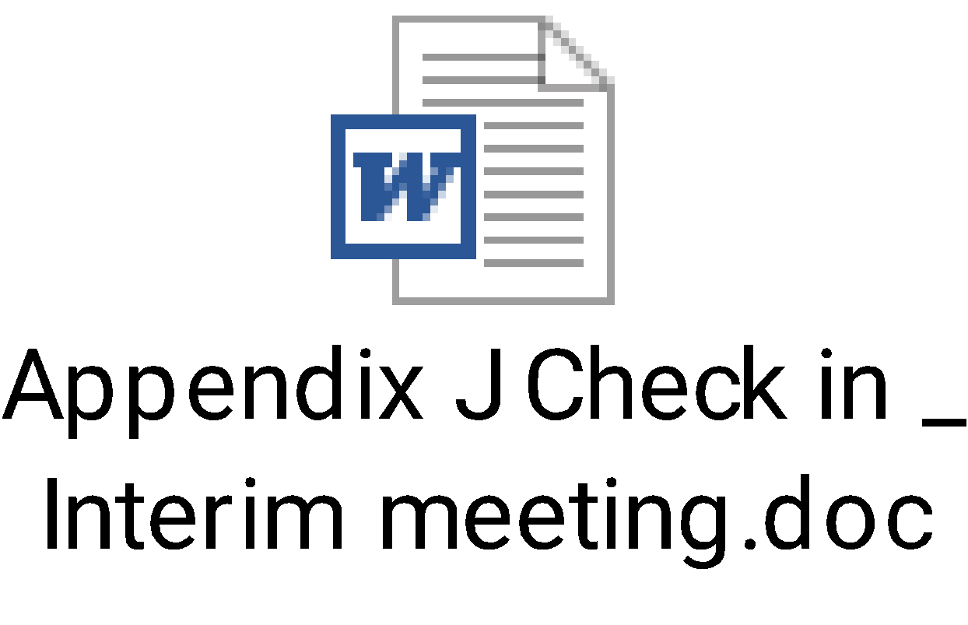

**Example documents for Teachers with Formal Leadership Responsibilities**

** **

** **

**Example documents for Teacher**

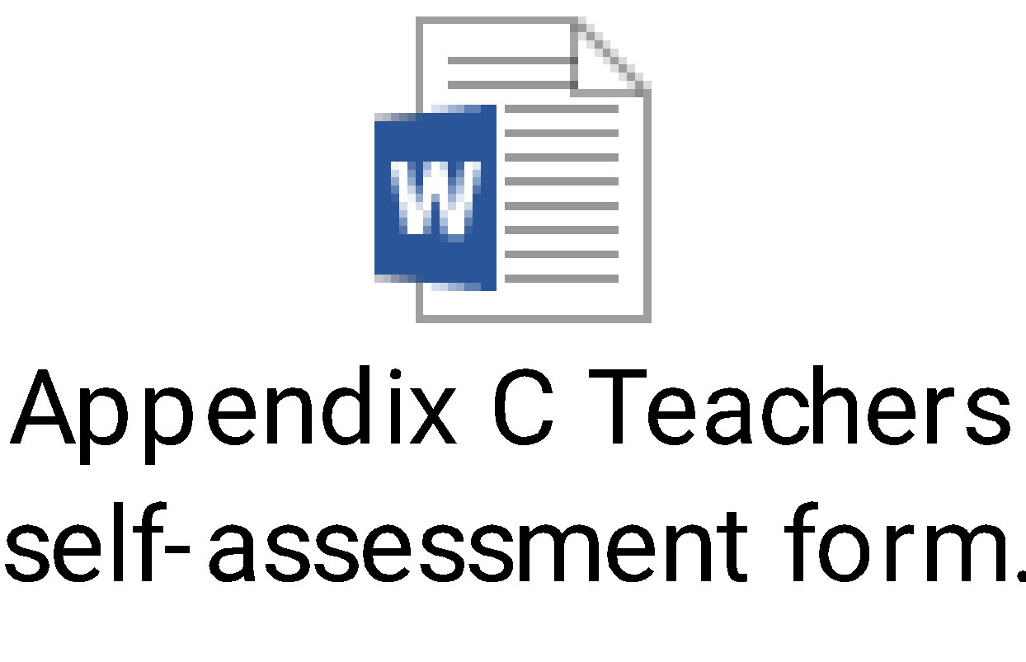  

 

**Example documents for Teaching Assistant**

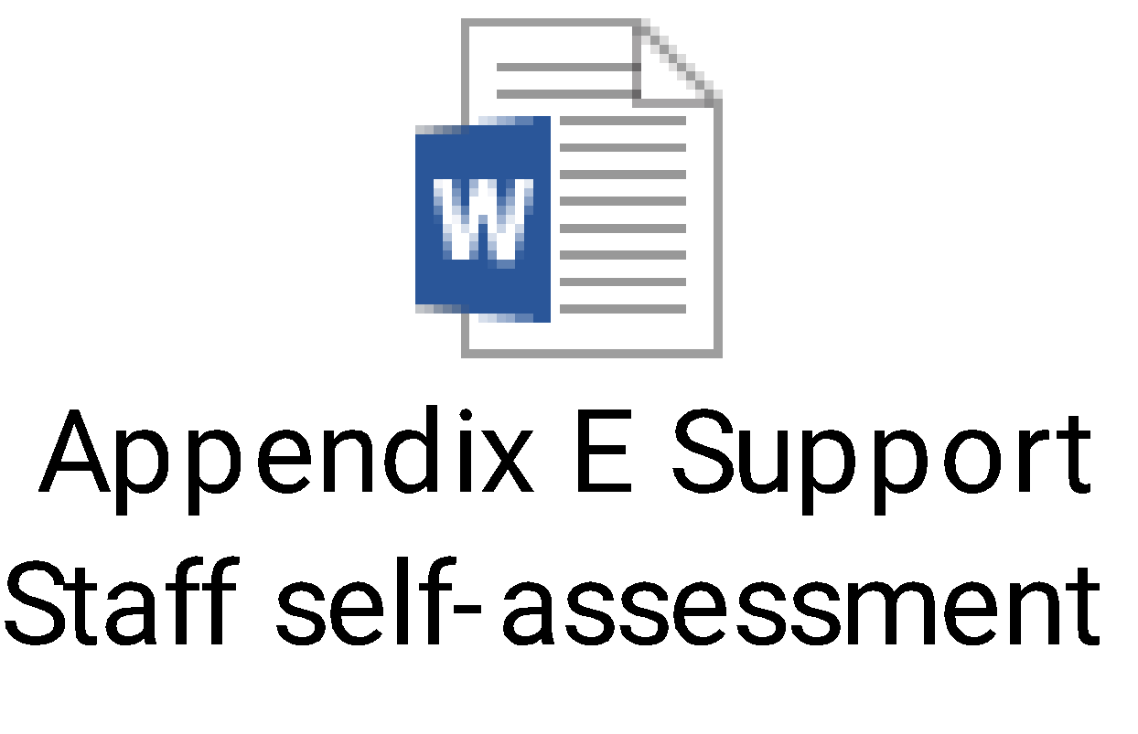   

 

**Example documents for Higher Level Teaching Assistant (HLTA)**

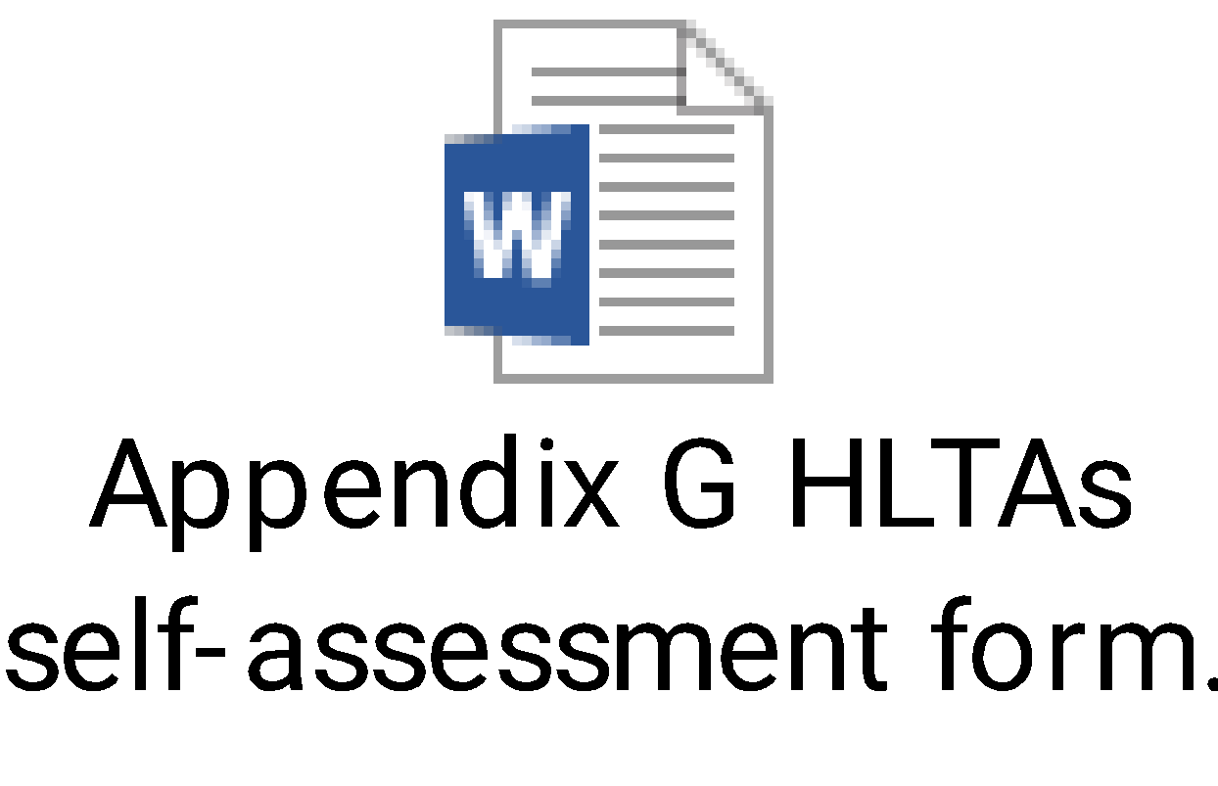  

 

*Appendix 1*

**Appeals Panel Members**

Any person appointed as an appeals officer or member of an appeals panel will not have participated in the review which is subject to appeal.

A School with a religious character

*Head Teacher*

Chair of Governors (or other governor where the Chair of Governors has participated in the head teacher’s review which is subject to appeal).

Two officers appointed by the local authority

One officer appointed by the Diocesan Authority

*Other members of Staff*

Head Teacher

*OR*

Chair of Governors (where the head teacher is the reviewer for the review which is subjected to appeal) plus an officer appointed by the local authority to assist the Chair of Governors

B All Other Schools

*Head Teacher*

Chair of Governors (or other governor where the Chair of Governors has participated in the head teacher’s review which is subject to appeal).

Another governor (excluding staff governors)

Two officers appointed by the local authority

*Other members of staff*

Head Teacher

*OR*

Chair of Governors (where the head teacher is the reviewer for the review which is subjected to appeal) plus an officer appointed by the local authority to assist the Chair of Governors